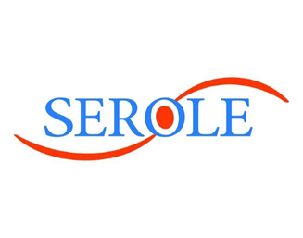



**elseco – Capacity Management**

**Serole**

**Technical Specification**

**Prepared By**

**Venu Alapati**

**Note to Holders:**

If you receive an electronic copy of this document and print it out, please write your name on the equivalent of the cover page, for document control purposes. If you receive a hard copy of this document, please write your name on the front cover, for document control purposes.

© 2021 Serole Technologies. All rights reserved. Specifications contained herein are subject to change without notice. The information shared in this document between elseco and Serole Technologies is proprietary and confidential. Serole Technologies, Serole logo, are trademarks or registered trademarks of Serole Technologies and other countries. All other brands or products are trademarks or registered trademarks of their respective holders and should be treated as such. Statements or representations in this proposal regarding characteristics and/or performance of Serole products and services are based on Serole’s current understanding of elseco Project requirements and environment, and are provided for informational purposes only.

Any technical or performance characteristics required to become contractual requirements must be identified in applicable contract documentation and agreed to in writing by Serole. This document contains information proprietary and confidential to elseco Limited Insurance Company and Serole, as indicated by the “Confidential” label on each page and must be held in accordance with the confidentiality terms provided herewith. Therefore, only those elseco Limited Insurance Company personnel who are evaluating the Serole proposal may have access to the information contained in this proposal, subject to the confidentiality terms provided herewith.

**Document Information**

**Stakeholders**

|  |  |  |  |
| --- | --- | --- | --- |
| **Serole Technologies** | | | |
| **Name** | **Project Role** | **Doc role** | **Status** |
| Venu Alapati | Professional Consultant | Authored |  |
| Murthy | Project Manager | Approved By |  |

**Table of Contents**

1. Objective – Application Levels 3

1.1 Agreement 3

1.2 Line of Business 3

1.3 Pool 4

1.4 Member 4

1.5 QS Agreement 5

1.6 QS Member 5

2. Overview of Technical Solution 6

2.1 Capacity Management Tile 6

2.2 Process Map 7

2.3 Front end View and Controller details 8

2.3.1 Technical Information 8

2.3.2 Claim Authority 8

2.3.2.1 Claim Authority Parameters 8

2.3.3 Commission Type with Flag 11

2.3.4 Combine Single Limit 12

2.3.5 Fronter Retention added at QS level 14

# Objective – Application Levels

# Agreement

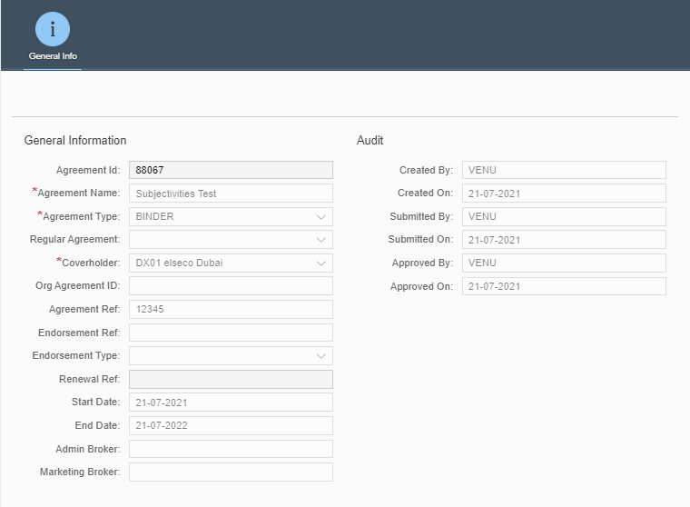

# Line of Business

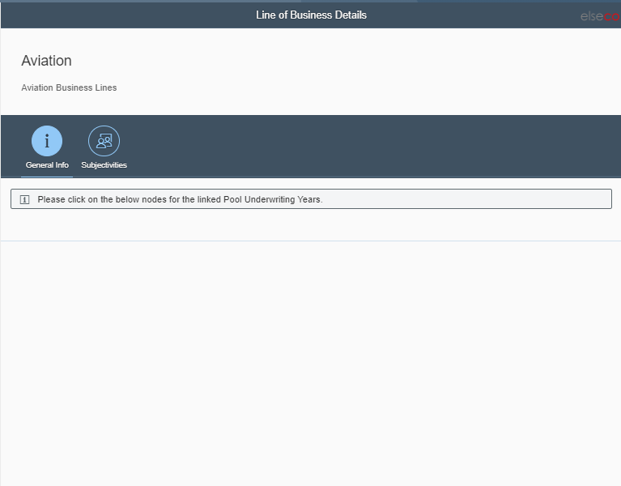

# Pool

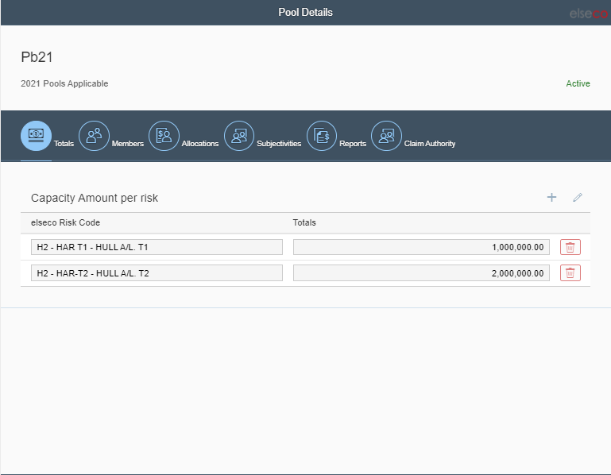

# Member

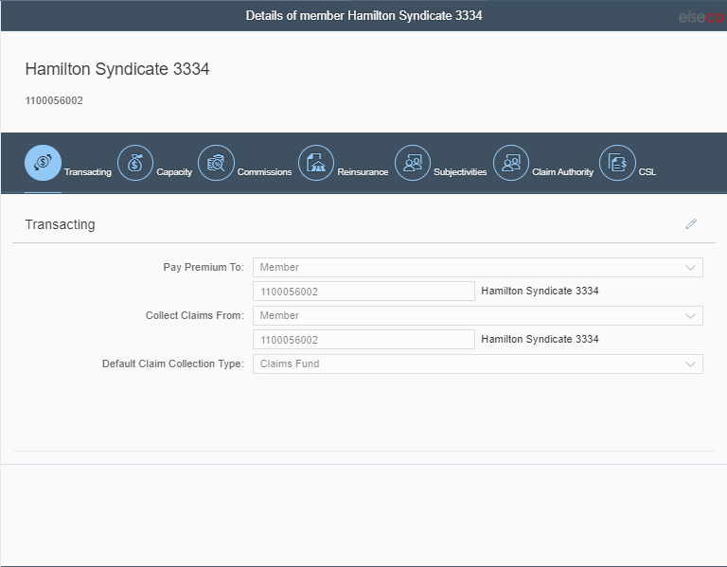

# QS Agreement

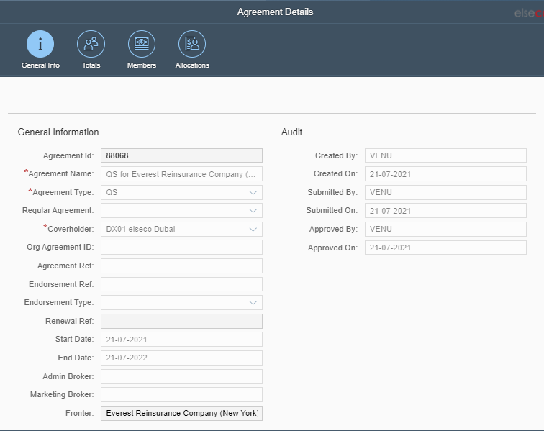

# QS Member

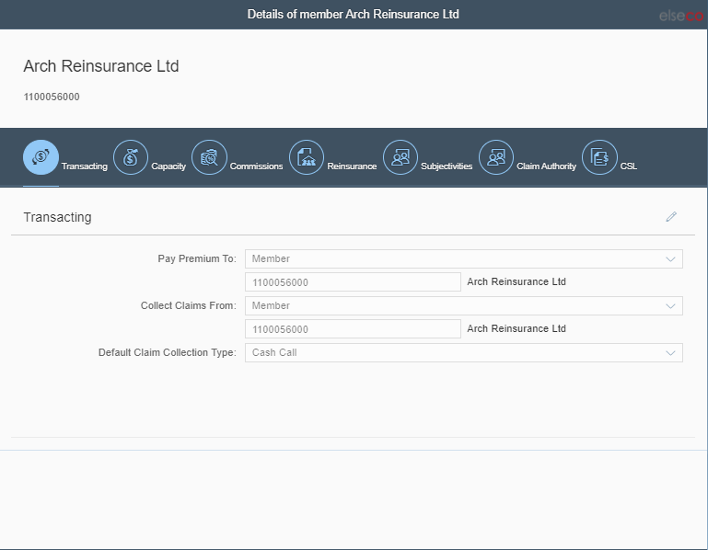

# Overview of Technical Solution

## Capacity Management Tile

Application will be accessed through Fiori Launchpad.

Example tile below:

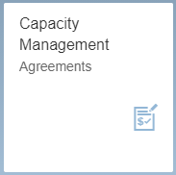

## Process Map

Agreement

* General Info
* General Info
* Subjectivities

Line of Business

* Totals
* Members
* Allocations
* Subjectivities
* Reports
* Claim Authority

Pool

* Transacting
* Capacity
* Commissions
* Reinsurance
* Subjectivities
* Claim Authority
* CSL

Member

* General Info
* Totals
* Members
* Allocations

QS Agreement

* Transacting
* Capacity
* Commissions
* Reinsurance
* Subjectivities
* Claim Authority
* CSL

QS Member

## Front end View and Controller details

## Technical Information

BSP application of the app is **YEL_CAPMAN** and Bit Bucket Project is **zui5capman.**

## Claim Authority

## Claim Authority Parameters

Limit Full Claims Authority $

Limit Full Claims Authority % of Max Limit

Limit Claims Authority with prior notification $

Limit Claims Authority with prior notification %

Limit Claim Expenses $

Limit Claim Expenses %

Restrict WP

Restrict Ex Gratia

Loss Fund Type

Loss Fund Amount

Loss Fund top up %

Adjusters Panel

Lawyers Panel

Authority to enter into market standard claim handling agreements

Authority to delegate claim authority

Authority to pay into working or revolving funds

Claim Authority Suspended?

that.getClaimAuthority(); Get claim authority details based on pool under writing year

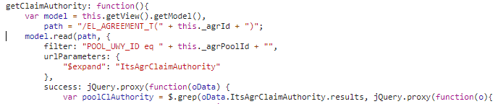

this.onAddClAuthorityPool: Add - Claim Authority

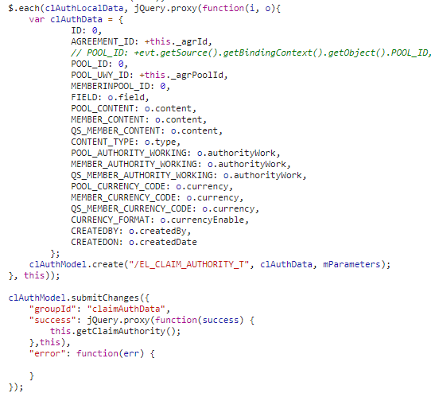

this.onSaveClAuthorityPool():- Edit - Claim authority

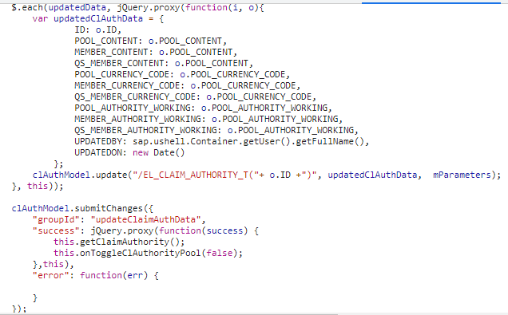

Output:-

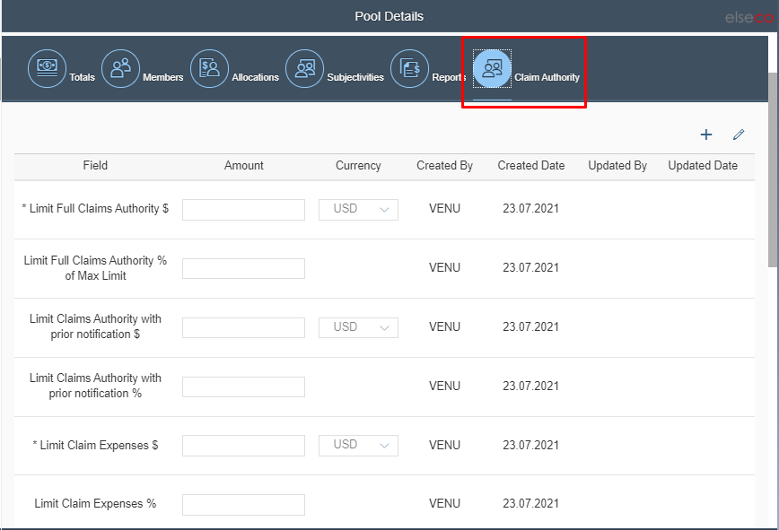

## Commission Type with Flag

Displaying the Group and Flag along with Commission Types

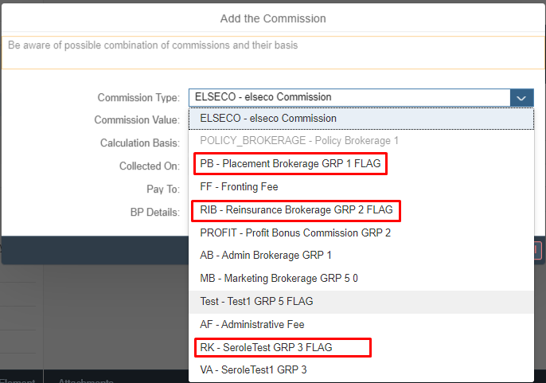

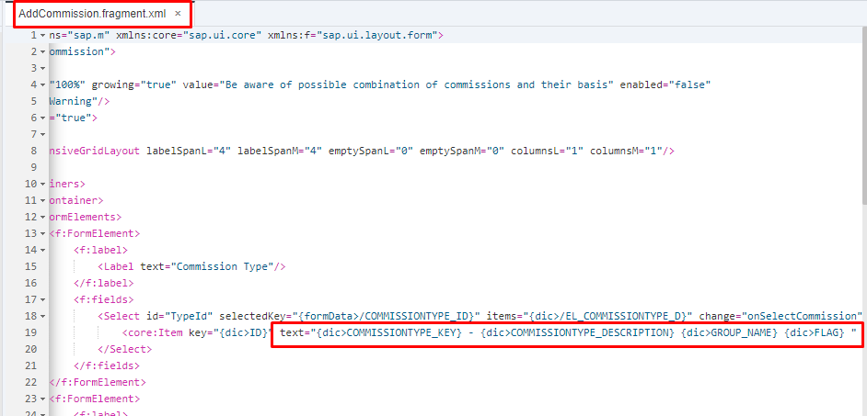

## Combine Single Limit

this. onAddCsl(): Add CSL

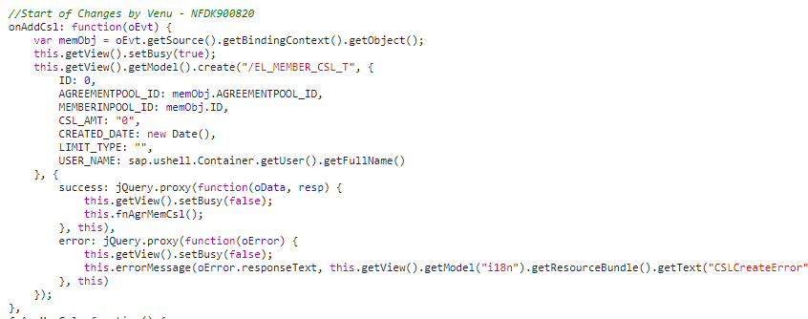

this.fnAgrMemCsl(): Get CSL data from backend

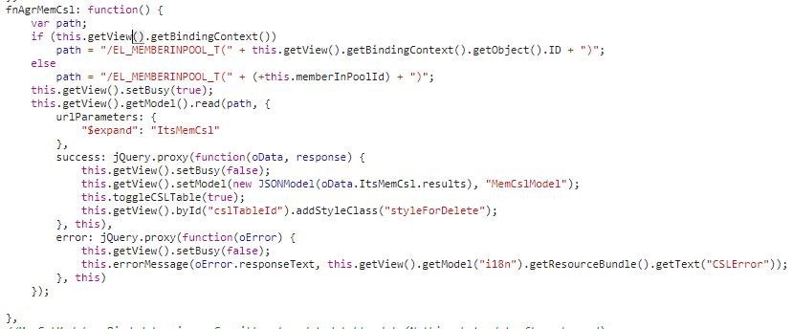

this.onSaveCsl(): Edit the CSL Data (Save)

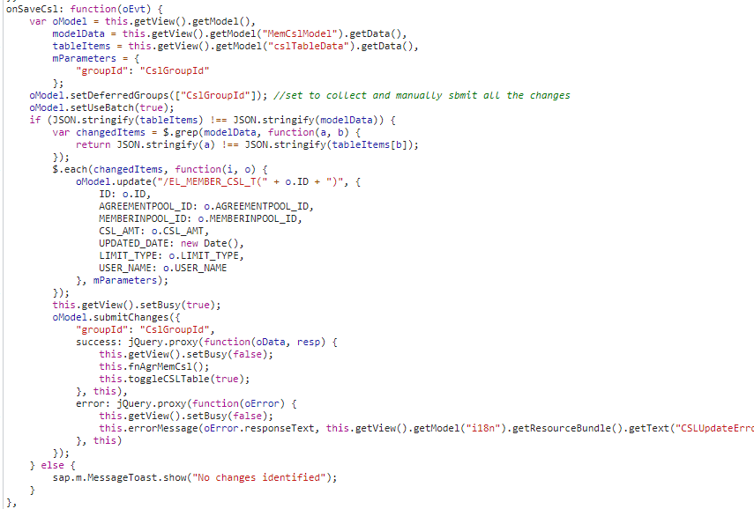

this.onDeleteCsl(): Delete CSL Record

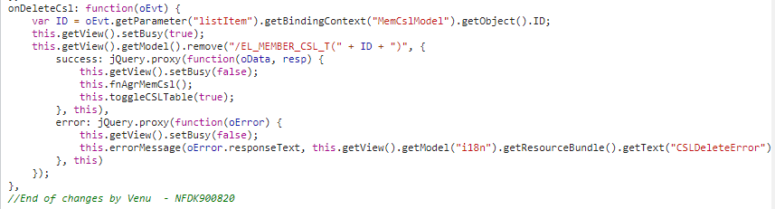

Output:-

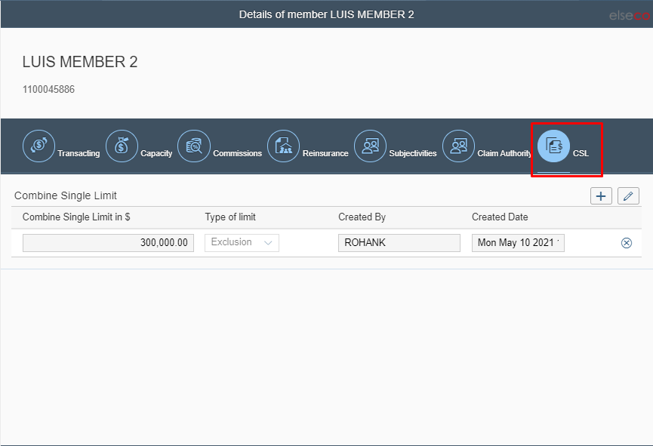

## Fronter Retention added at QS level

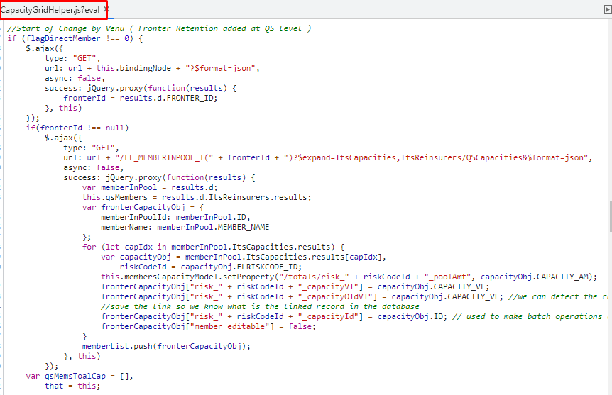

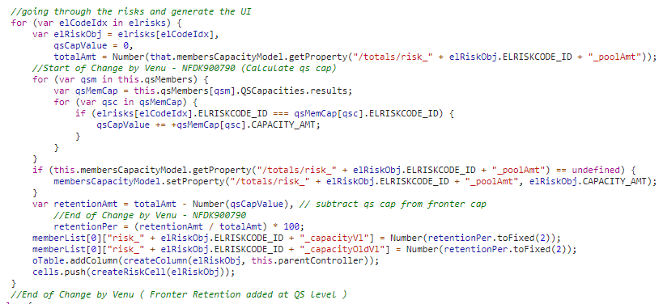

Output:-

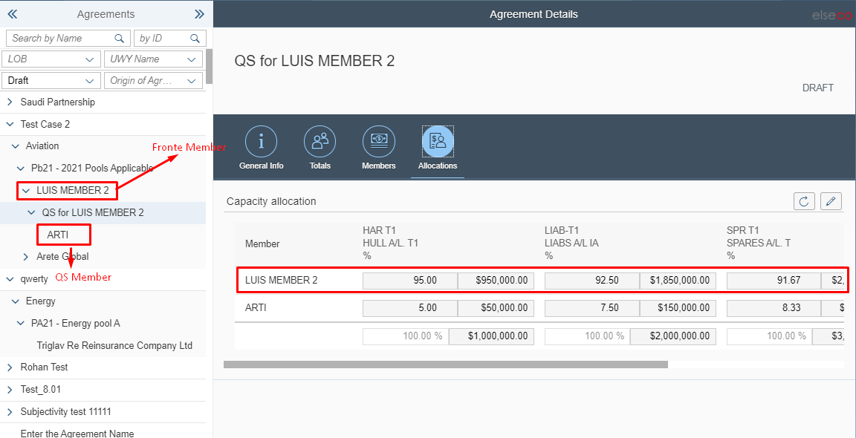

---------- ***End of Document*** ----------